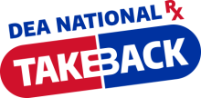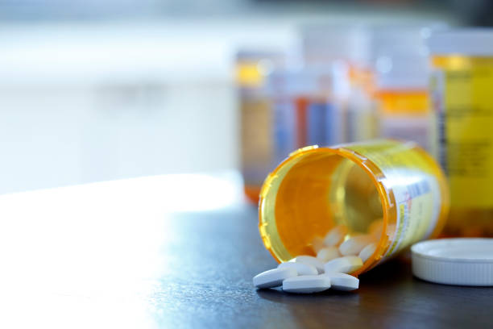

Emmanuel Baptist Church,

located at 11443 Laurel Bowie Road, Laurel, MD 20708,

in collaboration with the Prince George’s Department of Health will participate in

**THE NATIONAL PRESCRIPTION TAKE BACK DAY**

SATURDAY, OCTOBER 25, 2025

10 am – 2pm

This is a DRIVE THROUGH ONLY event

This is FREE and ANONYMOUS

**Acceptable items:**

* Prescription and OTC pills in a container,
* patches
* vaping devices and cartridges.

**Unacceptable items:**

* needles/syringes
* diabetic supplies
* devices with lithium batteries
* liquids

**IMPORTANT:** Remove labels from prescription bottles or blacken out personal information.

